1. Create a stored procedure in the Northwind database that will calculate the average value of Freight for a specified customer.Then, a business rule will be added that will be triggered before every Update and Insert command in the Orders controller,and will use the stored procedure to verify that the Freight does not exceed the average freight. If it does, a message will be displayed and the command will be cancelled.

alter PROC spAverageFreight

(

@CustomerID nvarchar(50),

@AvgFreight money OUTPUT

)

AS

BEGIN

SET @AvgFreight = ((SELECT AVG(Freight) FROM Orders WHERE CustomerID = @CustomerID))

SELECT @AvgFreight as AverageFreight

END

alter TRIGGER trForOrdersInsert

ON Orders

FOR INSERT,UPDATE

AS

BEGIN

DECLARE @ID nvarchar(50)

DECLARE @Freight money

DECLARE @AvgFreight money

SELECT @ID = CustomerID FROM inserted

SELECT @Freight = Freight FROM inserted

EXEC spAverageFreight @ID,@AvgFreight OUTPUT

IF @Freight > @AvgFreight

BEGIN

PRINT 'Freight Greater Than Average Freight'

ROLLBACK TRANSACTION

END

END

SELECT AVG(Freight) FROM Orders GROUP BY CustomerID HAVING CustomerID='RATTC'

select \* from Orders

insert into Orders ( CustomerID, EmployeeID, OrderDate, RequiredDate, ShipVia, Freight, ShipName, ShipAddress, ShipCity,ShipPostalCode, ShipCountry)

values('RATTC',2,'1998-05-12 00:00:00.000','1998-05-24 00:00:00.000',2,100,'Rattlesnake Canyon Grocery','2817 Milton Dr.','Albuquerque',87110, 'USA')

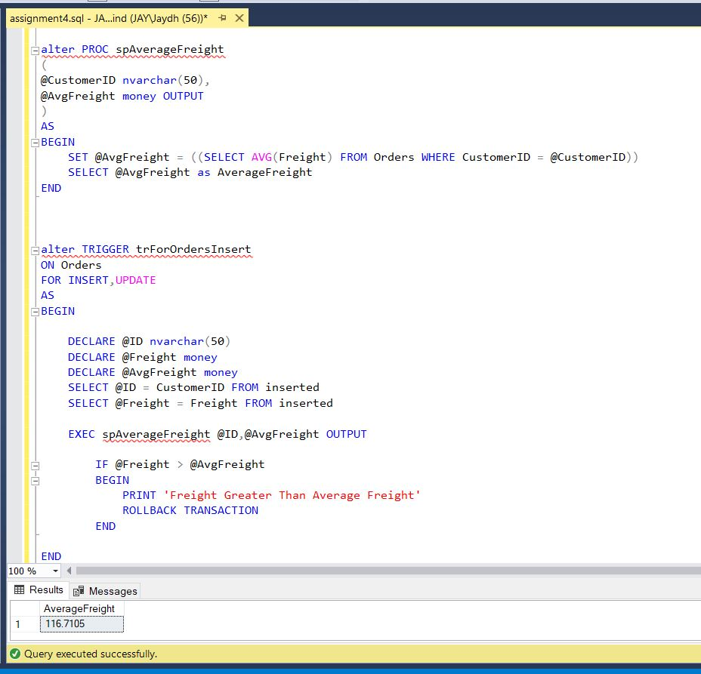

2) write a SQL query to Create Stored procedure in the Northwind database to retrieve Employee Sales by Country

alter Proc spGetEmpSalesByCountry

(

@InputCountry nvarchar(40)

)

as

begin

select e.FirstName + ' ' + e.LastName as employee,c.CompanyName, o.Freight,p.ProductName, od.UnitPrice,o.ShipCountry

from Employees e

inner join Orders o

on e.EmployeeID = o.EmployeeID

inner join Customers c

on o.CustomerID = c.CustomerID

inner join [Order Details] od

on o.OrderID = od.OrderID

inner join Products p

on od.ProductID = p.ProductID

where o.ShipCountry = @InputCountry

end

execute spGetEmpSalesByCountry 'USA'

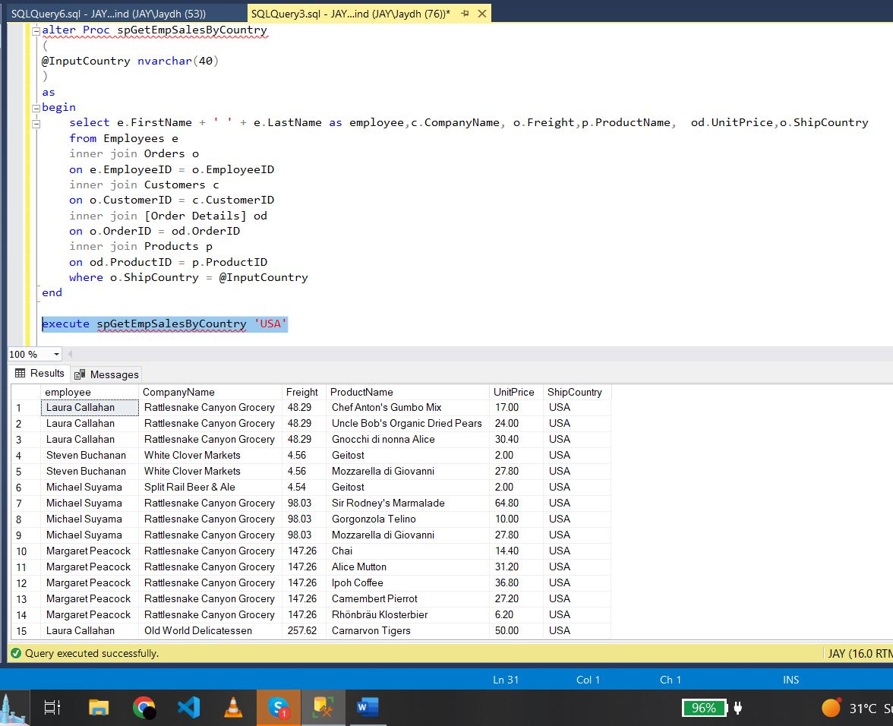

3) write a SQL query to Create Stored procedure in the Northwind database to retrieve

Sales by Year

select \* from Orders

select \* from [Order Subtotals]

alter proc spGetSalesByYear

(

@year int

)

as

begin

select o.OrderID,e.FirstName + ' ' + e.LastName as "employee name", o.ShippedDate, o.ShipCountry, os.Subtotal

from Orders o

inner join [Order Subtotals] os

on o.OrderID = os.OrderID

inner join Employees e

on o.EmployeeID = e.EmployeeID

where YEAR (o.ShippedDate) = @year

end

execute spGetSalesByYear 1997

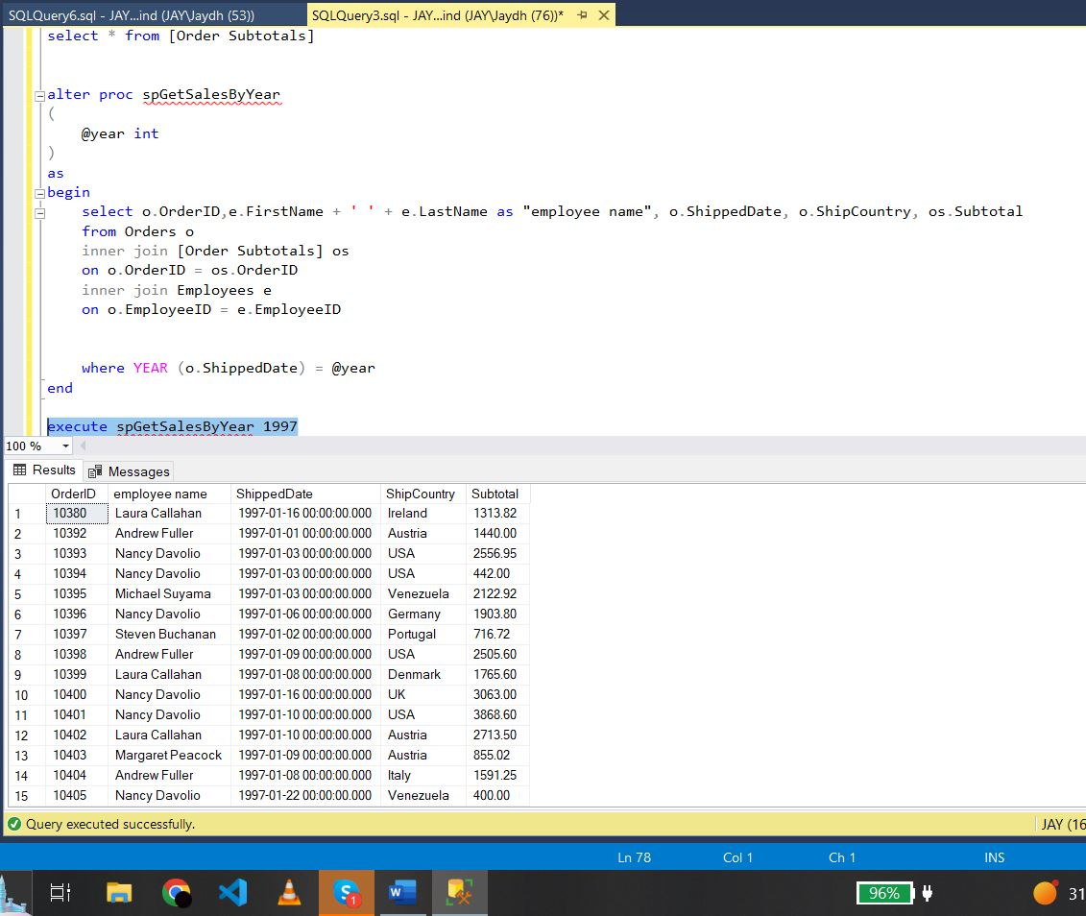

4) write a SQL query to Create Stored procedure in the Northwind database to retrieve

Sales By Category

select \* from Orders

select \* from Categories

select \* from Products

select \* from [Order Details]

alter proc spSalesByCategory

(

@sales nvarchar(50)

)

as

begin

select p.ProductName, od.Quantity, od.UnitPrice, o.ShipCountry

from [Order Details] od

inner join Orders o

on od.OrderID = o.OrderID

inner join Products p

on od.ProductID = p.ProductID

inner join Categories c

on c.CategoryID = p.ProductID

where c.CategoryName = @sales

end

execute spSalesByCategory 'Beverages'

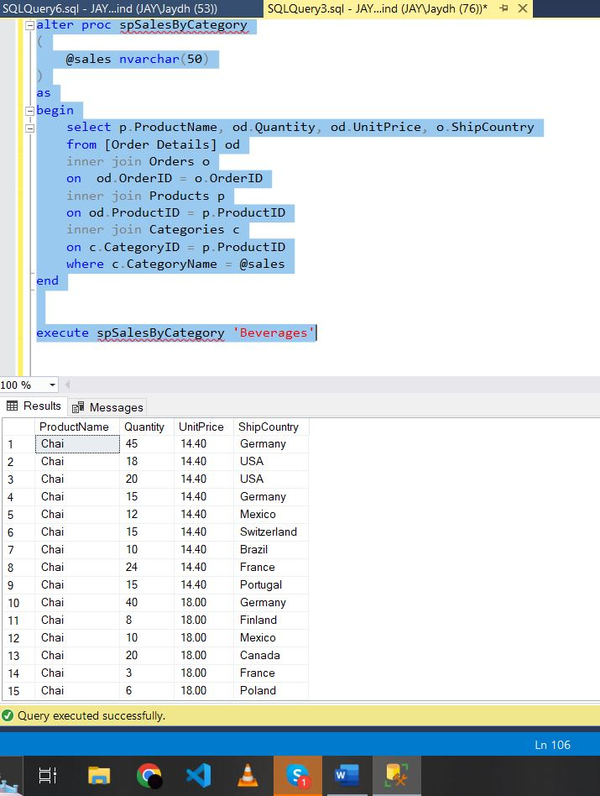

5) write a SQL query to Create Stored procedure in the Northwind database to retrieve

Ten Most Expensive Products

alter proc spTopTenExpensiveItems

as

begin

select top(10) p.ProductName, p.UnitPrice

from Products p

order by UnitPrice desc

end

execute spTopTenExpensiveItems

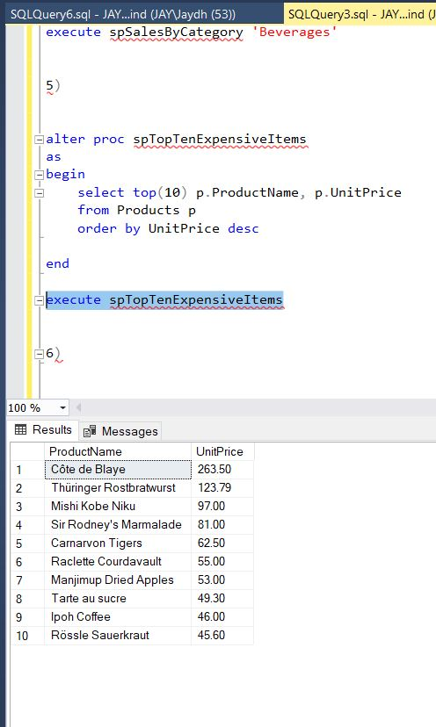

6) write a SQL query to Create Stored procedure in the Northwind database to insert

Customer Order Details

alter proc spInsertCustomerOrderDetails

(

@Orderid int,

@pID int,

@unitPrice decimal(5,2),

@Totalitems int,

@discount int

)

as

begin

Insert into [Order Details] values (@Orderid , @pID , @unitPrice , @Totalitems , @discount )

end

execute spInsertCustomerOrderDetails 10249, 72, 15.00, 30, 0.10

SELECT \* FROM [Order Details]

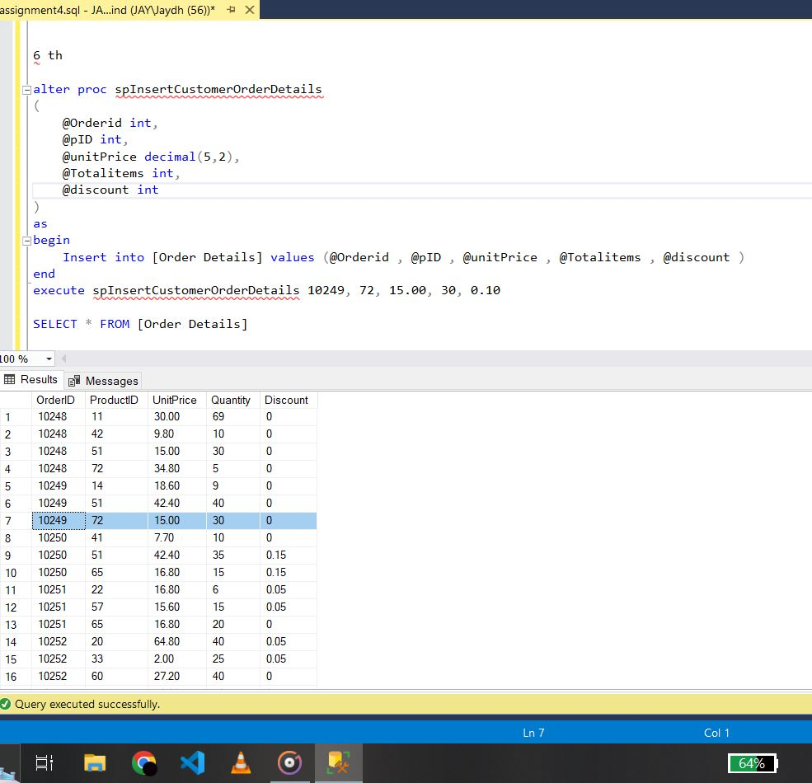

7) write a SQL query to Create Stored procedure in the Northwind database to update

Customer Order Details

alter Proc spUpdateCustomerOrderDetails

(

@orderid int,

@productid int,

@unitprice decimal(5,2),

@Totalitems int

)

As

Begin

Update [Order Details]

set UnitPrice=@unitprice,

Quantity=@Totalitems

where ProductID=@productid and OrderID=@orderid

End

Execute spUpdateCustomerOrderDetails 10248, 11, 30.00, 69

SELECT \* FROM [Order Details];

